Name : Wong Wai Fun Student ID : 20138073 Assignment 2

Effect : Roughen

Effect: **Histogram and Contrast**

(value)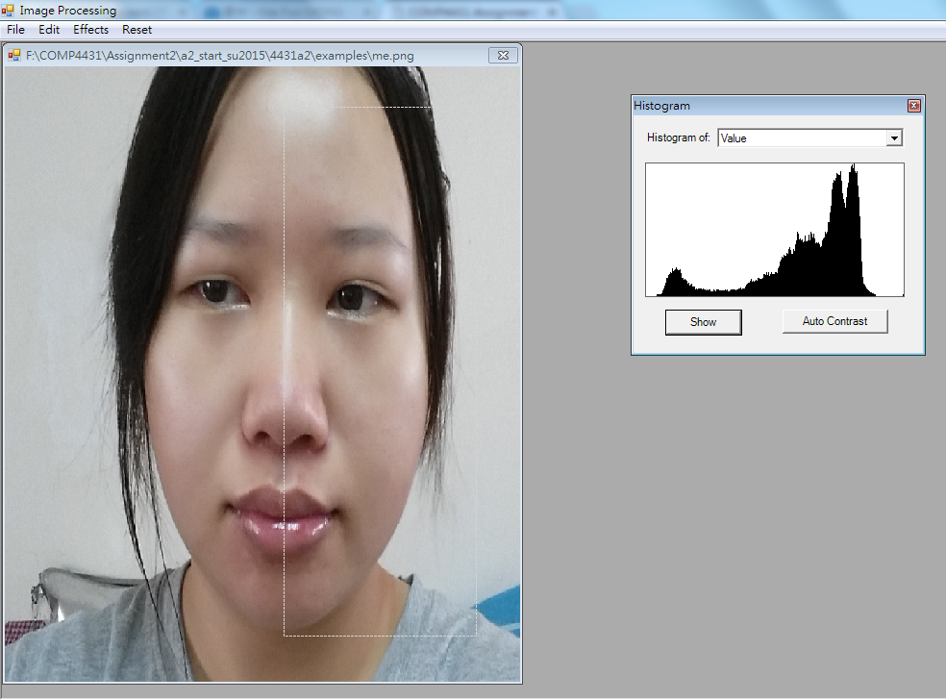

(red)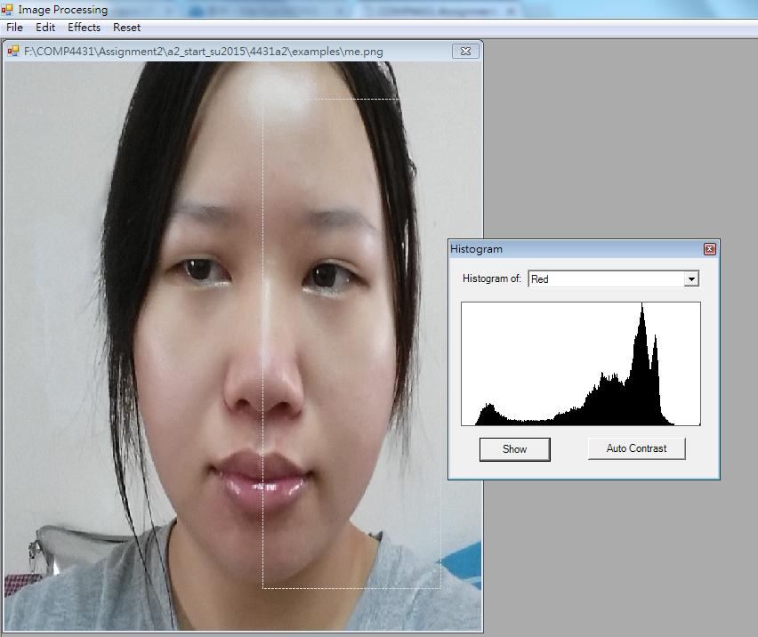

(green)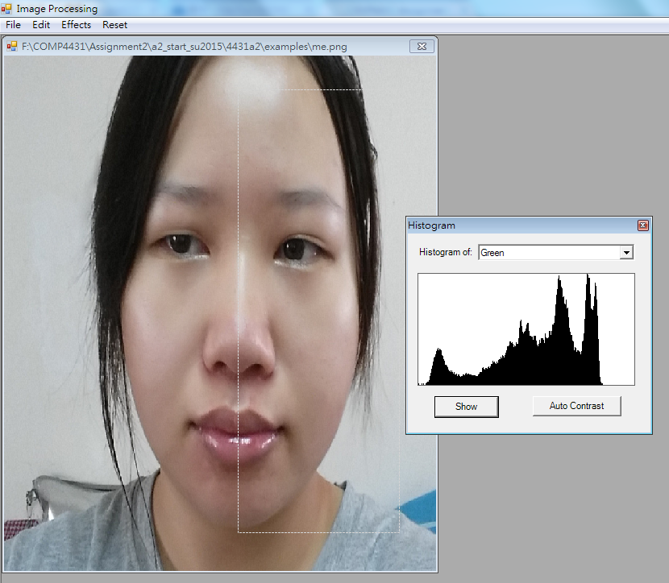

(blue) 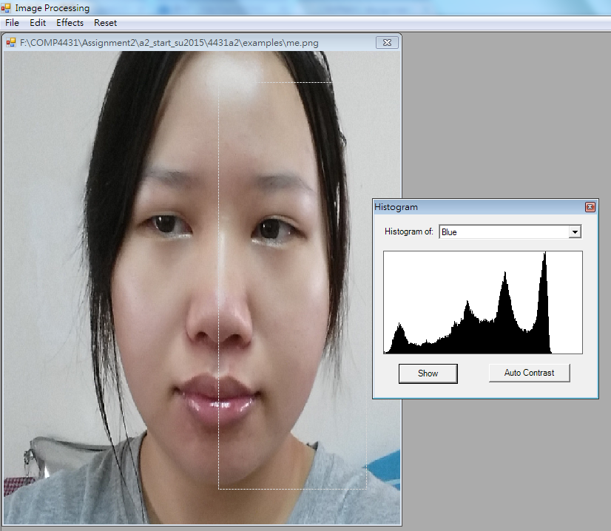

(Auto Contrast) Left(before)/Right(after)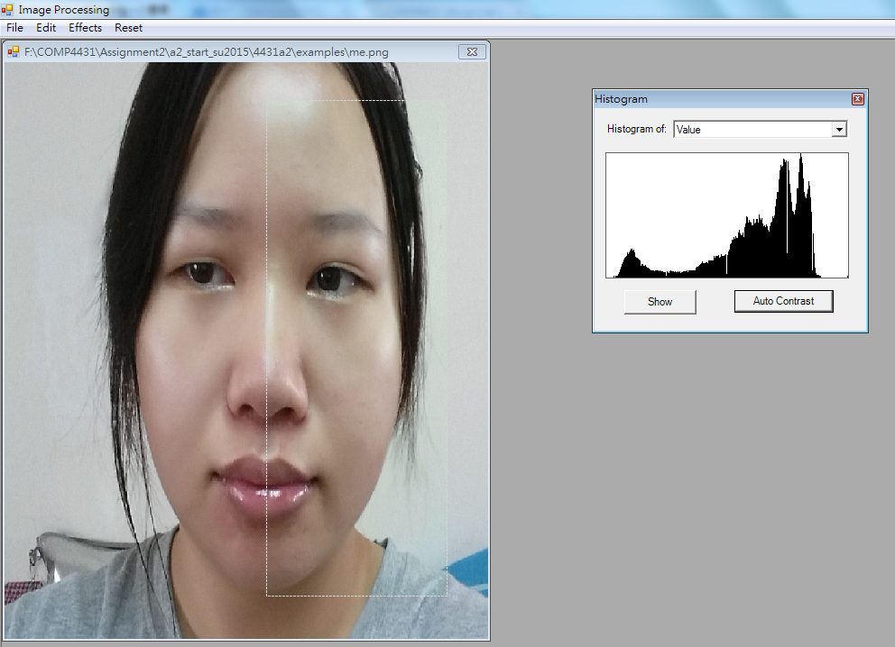

**Effect : Customized Blur Kernel**

Small kernel

Large kernel

**Effect : Background removal**

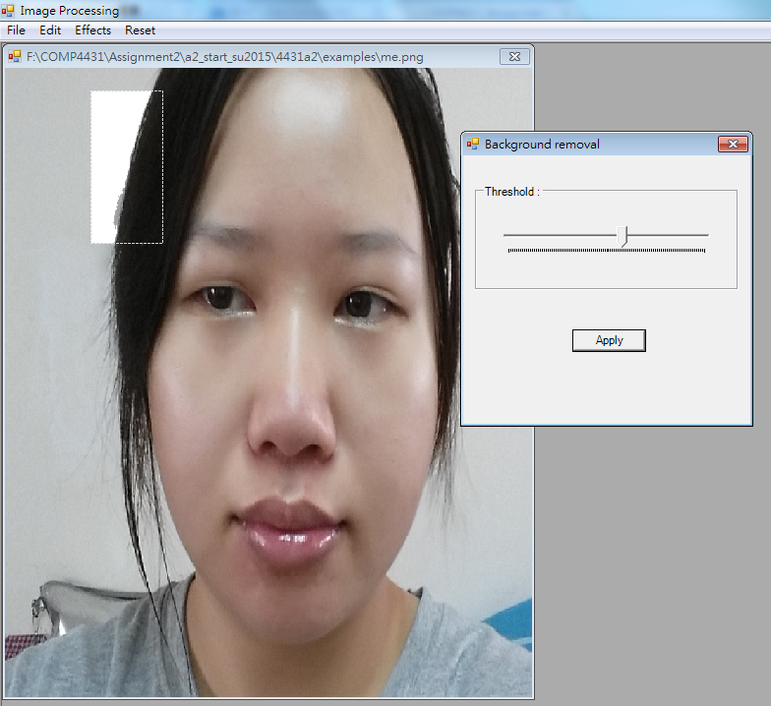

**Effect : Melt**

**Effect : Rotate**

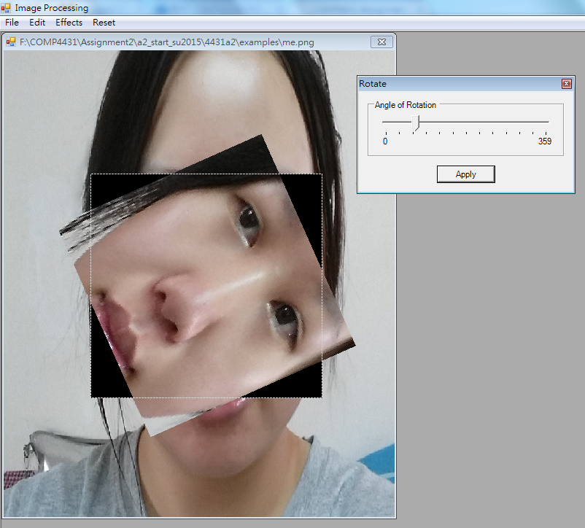

**Effect : Edge Detection**

**Effect : Ripple**

**Left (before) / right (after)**

